Would you like to borrow eBooks or Audio Books?

The Simpson Memorial Library is pleased to offer access to the Maine InfoNet Download Library.

You can borrow either downloadable audio books for transfer to devices such as an iPod or other MP3 player, or eBooks for use on devices such as an iPad/iPhone, Kindle, Nook, Sony eReader and Kobo, among others.

- To log in, go to http://download.maineinfonet.org. You will need your 13-digit SML library card number (the bar code on the back of your card) in order to log in.
- Click the account icon in order to log in.
- Type Simpson Memorial in the library name field. The field will suggest names. Choose Carmel: Simpson Memorial Library from the list.
- Enter your library card number and click the Sign In button.
This will show your bookshelf and any books signed out by you (if any)
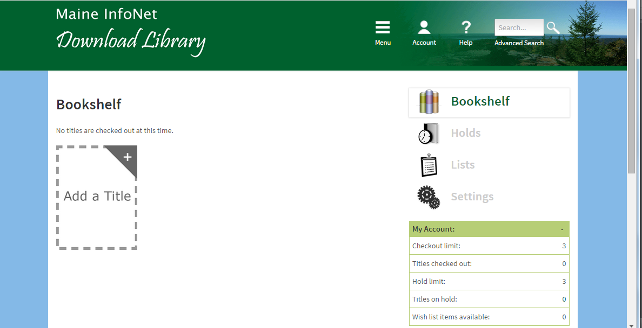
- To look for either eBooks or audio books, click on the menu icon and choose a category that interests you.
- From here you can preview or request books.

For additional help, when you are on the InfoNet site, click the help icon to go the help page.

